Bank Account Opening Form

Passport-size photo of the applicant

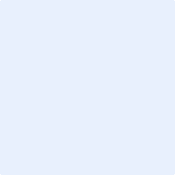

**Dutch-Bangla Bank Limited**

(Branch)

**Date:** 19 December 2024

|  |  |  |  |  |  |  |  |  |  |  |
| --- | --- | --- | --- | --- | --- | --- | --- | --- | --- | --- |
|  |  |  |  |  |  |  |  |  |  |  |

**Customer ID:**

**Personal Information\***

**Name:**

Last Name

First Name

**Mr.**

|  |  |  |
| --- | --- | --- |
|  |  |  |

Day Month Year

**Date of Birth\***

**Father’s / Mother’s Name: Contact Number:**

Enter Full Name

+880XXXXXXXXXX

Enter Email Address

**E-mail:**

**Address\***

City

Country

Enter Street Address Line 2

Enter Street Address

Postal/Zip Code

State/Province

**Education Level\***

**High School or below**

**Undergraduate**

**Master’s Degree**

**PhD**

**Form of Identification\***

**National Identity Card**

**Driver’s Licence**

**International Passport**

**Student ID**

**Account Information\***

**Fixed Deposit Account**

**Account Category:**

**Recurring deposit account**

**Account Types:**

**Monthly Salary:**

BDT

